 | ACCEPTED MANUSCRIPT  YOUR INTRODUCTION TO THE LANGUAGE EDITING PROCESS | COVER  PAGE
AOSIS would like to take this opportunity to inform you that the copy-edited (i.e. language edited) version of your manuscript, has been completed for your review. Your manuscript will follow after the Manuscript Information Page.

Kindly note that the publisher has to receive your manuscript within two working days from you, unless alternative arrangements have been made with us. Please make the necessary arrangements to ensure that you have ample time to review your manuscript.

Your manuscript has been accepted for publication after being subjected to a blind peer review process. Please note that we do not allow large new portions of text (ideas or concepts) to be introduced to the manuscript after it has been accepted for publication. If large portions of text are inserted into the manuscript we will transfer it back to the review-stage for another round of peer review, which will cause a delay and added expenses in the publication of your manuscript.

To avoid publication delays we ask that you carefully scrutinise the changes that have been suggested by the professional language editor. Please ensure that you have enabled the ‘track change’ function in your version of Microsoft Word prior to addressing all points of concern by:
- answering all questions posted by the language editor.
- providing omitted information both in terms of the content of the manuscript and the references.
- making your changes in “Track Changes”; please remember to leave the existing comments (please do not delete comments)– this will assist our language editor with the preparation of your manuscript for layout.

Kindly note that incomplete manuscripts will be sent back to the author for rectification.

Understanding your language controlled manuscript:
‘Headings’ should be numbered. Kindly assist us in identifying your headings, by their hierarchical level as per the following example:
1. First level headings
1.1. Second level headings
1.1.1. Third level headings
1.1.1.1. Fourth level heading
The numbered heading serves as guides for the galley creation phase only. No manuscript will be published with numbered headings, refrain from referring to numbered headings in the body of your manuscript.

‘Track Changes’ is a way for Microsoft Word to keep track of the changes that our copy-editors make to a manuscript.
- Please do not choose to accept Track Changes.
- Please do not reject suggested edits; rather make a separate comment stating your reason for rejection.
For more information on how ‘Track Changes’ works, please consult the Help function within your version of Microsoft Word.

‘Comments’ is a way for the copy-editor to make a note at a specific point in the manuscript.
- Please do not delete the comment, either add your own comment in response or add your feedback within the posted comment.
For more information on how ‘Comments’ works, please consult the Help function within your version of Microsoft Word.

Completed your review of the copy-edited manuscript?
It is time to Upload your completed review of the manuscript on the online journal website. Please follow the steps:
- Log into the journal website with your unique username and password.
- Click on ‘Author’ under your User Home.
- Click on the status link next to your active submission in the ‘Active Submissions’ table.
- At your manuscripts ‘Editing’ page, under ‘Copy-editing’ Step 2 please select browse and select your review of the copy-edited manuscript from where you saved in on your computer. Proceed to select Upload. A file will be under Copyediting point 2 called ‘Author Copyedit’; this means you have successfully uploaded a file. Ensure that this is the correct file by downloading it and checking that it is in order.
- To complete the process, you will need to inform the copy-editor that you have completed the review of the document. Please click on the envelope icon under complete (circled) and send an email to the copy-editor.
- Congratulations! you have successfully reviewed your language edited document.

FOR OFFICE USE – CORRESPONDING AUTHOR INFORMATION
Name | Sonja Grater
Email | sonja.grater@nwu.ac.za

 |  | ACCEPTED MANUSCRIPT  MANUSCRIPT INFORMATION PAGE  (AUTHOR TO VERIFY) |  |  | YOUR REFERENCE NUMBER: 772
This manuscript information page, includes manuscript and author identification information which was removed during the peer review process. Kindly review all information and ensure that it reflects the original submitted manuscript. Any form field shaded light ‘blue’ requires the corresponding authors’ confirmation and/or completion.
MANUSCRIPT INFORMATION PAGE
Manuscript title |  | Analysing the impact of COVID-19 trade disruptions on port authority pricing and container shipping in South Africa
Manuscript abstract |  | Background: The COVID pandemic directly affected the shipping industry globally, and South Africa felt the impact through lower cargo volumes and higher freight rates. In addition, National Ports Authority (NPA) charges are 69% and cargo dues 166% above the global benchmark mean. The NPA use a rate of return (RR) model to calculate tariff increases that are contested by port stakeholders.  Objectives: This study analyses the impact of COVID-19 trade disruptions, and examines the associated higher liner freight rates, tariff applications for higher NPA tariffs, and reduced CAPEX investment in port infrastructure. It aims to show that adjustments to the RR model variables can result in large savings in costs for port users.  Method: The study analyses the impact of the pandemic on cargo volumes and freight rates in South Africa. It critiques the Regulatory Asset Base (RAB), the asset beta, the tax rate to be applied and calculates the adjustments to these RR model variables and shows the results under five scenarios.  Results: Results show a sharp decrease in cargo volumes during COVID lockdowns, and a parallel increase in freight rates. The RR model results show how the NPA tariff adjustments could have been much lower. Even a tariff decrease of 5.76% in scenario four, and a 20.32% decrease in scenario five.  Conclusion: Amid the global rise of shipping rates and the economic impact of the pandemic on South Africa’s trade, results show that there is a potential to enhance SA’s trade competitiveness through a decrease in NPA weighted average tariff by 20%.
Manuscript keywords |  | COVID-19; Port Pricing; Port Authority; Ports Regulator of South Africa; Shipping; South Africa
Number of authors |  | 2
Acknowledgements |  | none
Competing interests |  | No competing interest
Author(s) contributions |  | Sonja Grater and Mihalis Chasomeris conceived of the presented idea. Both authors developed the theory and Sonja Grater wrote the majority of the literature background. Sonja Grater performed the computations in section 3.1. Mihalis Chasomeris contributed to the literature background and performed the computations and analytical work in section 3.2, 4 and 5. All authors discussed the results and contributed to the final manuscript.
Funding Information |  | This research received no funding
Data availability statement |  | All data used was secondary and obtained from publically available databases.
Disclaimer |  | The views and opinions expressed in this article are those of the authors and do not reflect the official policy position or position of the affiliated organisations of the authors.
Ethical consideration Statement (include number) |  | Graduate School of Business and Leadership, University of KwaZulu- Natal has granted Exemption from Ethics Review. 00014026
Project research number (if applicable)
TRANSLATIONS: ONLY APPLICABLE FOR NON-ENGLISH MANUSCRIPTS (OR JOURNALS REQUESTING ANOTHER LANGUAGE FOR ABSTRACTS)
Manuscript title in another language |  | Not applicable, no action required from author.
Manuscript abstract in another language |  | Not applicable, no action required from author.
Manuscript keywords in another language |  | Not applicable, no action required from author.
Please list ALL AUTHORS in the same order as they should appear on the published submission. Any deviation from the original submitted manuscript regarding the following list, will result in an ‘AUTHORSHIP CHANGE FORM’ that must be completed by all authors when:
- New author(s) have been added
- There is a change in the order of authorship
- An author wishes to remove his/her name. An author’s name may only be removed at his/her own request and a letter signed by the author should accompany this form
- An author wishes to change affiliation before publication of the article.
Order | Author Name | Author Affiliation | Country | ORCID† |  | Twitter username*
1st | Sonja Grater | School of Economics, Faculty of Economic and Management Sciences, North West University, Potchefstroom | South Africa | https://orcid.org/0000-0001-7290-0313
2nd | Mihalis G. Chasomeris | Graduate School of Business and Leadership, University of KwaZulu-Natal, Durban | South Africa | https://orcid.org/0000-0003-0920-7537
† An ORCID is a persistent digital identifier that distinguishes you from every other researcher. For more information, see here: http://www.orcid.org
* A twitter username is how you're identified on Twitter, and is always preceded immediately by the @ symbol. For instance, Katy Perry is @katyperry. For more information, see here: http://www.twitter.com
MANUSCRIPT MARKETING & DISTRIBUTION
AOSIS requires the corresponding author to provide the following:
Provide a shortened/news worthy manuscript title for twitter?
Note: 101 characters with spacing
Optional: Indicate whether there is a media item (photo/figure/table) within your manuscript which would be appropriate to accompany the manuscript media posting on twitter?
 |  |  | FOR PUBLISHING OFFICE USE ONLY
 |  |  | Allocated Journal Section |  |  | Original Research - Special Collection: Impact of COVID-19 on the transport and logistics management
 |  |  | Date submitted YYYY-MM-DD |  |  | 2022-03-29
 |  |  | Date accepted YYYY-MM-DD |  |  | 2022-05-17
 |  |  | Any author change request during review |  |  | ☐ Yes ☒ No
 |  |  | No. of Figures |  |  | 3
 |  |  | No. of Tables |  |  | 1
 |  |  | No. of Other |  |  | 1 EQA
 |  |  | Notes for production team:

- Introduction

The COVID-19 pandemic has created fundamental challenges for the global economy. Global GDP showed a severe decline in 2020, which was especially felt by developed economies (United Nations, 2020). The World Bank (2022) predicts global economic growth to decelerate to 4.1 percent in 2022, reflecting continued COVID19 flare-ups, reduced fiscal support, and continuous supply bottlenecks. Emerging economies are experiencing weaker recoveries as a result of slow vaccination progress and limited policy responses.
Global trade also decreased significantly, and foreign direct investment (FDI) followed suit. As a result, the situation highlighted severe vulnerabilities in global supply chains, many of which were not prepared for the unexpected disruptions (Veselovská, 2020).
Supply chains are sensitive to high-impact events, which can cause various levels of decline in consumption, trade and transportation (Notteboom et al, 2021). Consumption patterns during such events are affected by a loss of spending capacity by consumers, which in turn cause firms to experience a decline in demand and a parallel reduction in inventory levels. Bottlenecks through supply chains globally has led to a surge in order backlogs and record-high shipping prices (World Bank, 2022). Significant production problems occurred in most Asian countries and were amplified as other regions struggled to acquire sufficient industrial inputs for manufacturing (Baldwin and Freeman, 2020).
These events caused unprecedented impacts on the port and shipping industries specifically (Notteboom, Pallis and Rodrigues, 2021). Global supply chains are underpinned by maritime transport, with shipping estimated to handle over 80% of global goods trade (UNCTAD, 2021a). Developing countries are heavily dependent on maritime transport for access to global markets. In the first 24 weeks of 2020 alone, global ship calls declined by 8.7%, and when countries started to impose economic and social restrictions, and the number of ship calls fell by up to 20%.
For South Africa the impact was equally devastating, and it was exacerbated by a set of other events before and after the COVID-19 pandemic outbreak. Before the pandemic, South Africa already found itself in an economic recession and increasing unemployment levels (Makokera & Makokera, 2020). The World Bank Global Economic Prospects report (World Bank, 2022) estimated a GDP growth rate of 4.6% for South Africa during 2021, and a forecasted growth rate of only 2.1% in 2022. Persistent unemployment, inequality, rising government debt and structural impediments to growth are predicted to continue having a significant impact on the country’s recovery.
During COVID-19, the shipping industries in South Africa were hit equally hard. UNCTAD (2021a) reported that the ship calls to port in 2020 declined by 9.7% in Sub-Saharan Africa. For the Port of Durban, a 6.6% drop in ship carrying capacity in the first quarter of 2020 was reported, and in the second quarter, the port lost 5% of liner shipping services, 6.2% of ship calls and 2.8% of the deployed capacity.
South Africa then also faced other significant events. The World Bank (2021) ranked the South African ports in the bottom five of the world’s 351 competent container handling facilities in 2021. The Port of Durban was ranked position 349, Ngqura ranked at position 351, Port Elizabeth ranked at position 348 and Cape Town ranked at position 347. This ranking reflects poor port performance and productivity, which puts into question the ability of South Africa’s ports to remain competitive, especially with the additional pressures of the COVID-19 pandemic.
The National Ports Authority (NPA) are the single landlord for South Africa’s eight commercial ports. The NPA provides the port infrastructure and marine services. The NPA is regulated by the Ports Regulator of South Africa (PRSA). The NPA is a division within Transnet SOC Ltd., a state-owned logistics company. The NPA Act 2005 stated that the NPA should be incorporated as a subsidiary of Transnet, nevertheless, the NPA remains a division of Transnet.
Other contentious issues surrounding port pricing and a lack of infrastructure investments also occurred (Meyiwa and Chasomeris, 2020). Chasomeris and Gumede (2022) note that the NPA annual profit before tax increased 155% from R2.9 billion in 2017 to more than R7.4 billion in 2019. Over the same period, the PRSA granted an increase in planned capital expenditure (investment) from R4.1 billion to R5.4 billion. Actual capital expenditure, however, declined 55% from just over R2 billion to R905 million. In 2019/20 there was some increase in actual spend to R1.598 billion. However, the impact of COVID-19 may partly be seen in the significant decline in investment spending to R684 million in 2020/21. TNPA (2021) explain that this reduced investment was largely due to the COVID-19 pandemic and the lockdowns impact on economic activity.

South Africa was further affected by extreme riots in Kwa-Zulu Natal province in July 2021, and cyber-attacks on Transnet in the same period where the Transnet information technology system was hacked (Smith, 2021). These events further exposed the vulnerability of South Africa’s ports.
This study aims to analyse the impact of COVID-19 trade disruptions, and shows the adverse effects of the pandemic, including higher liner freight rates, tariff applications for higher National Port Authority tariffs, and reduced CAPEX investment in port infrastructure by the National Ports Authority.
The PRSA (2021) benchmarking study shows that South Africa’s port authority charges are 69% above the global benchmarked mean and that cargo dues are 166% above the mean. The NPA and PRSA use a rate of return model, known as the Revenue Required (RR) model, to calculate annual revenues and the annual port authority tariff adjustments. The value of several components of the RR model applied by the NPA are contested by port users and stakeholders (Chasomeris 2015; Gumede and Chasomeris 2017; Meyiwa and Chasomeris 2020). This study calculates evidence-based adjustments to the RR model variables and shows the results under five distinct scenarios. Such results will show that there is a potential to reduce NPA weighted average tariffs by as much as 20%.

- Global impact of COVID-19 on the ports and shipping industry:

Ferry services and the cruise industry were the two shipping industries that were impacted the most by the pandemic, since they are most closely linked to personal mobility and cross-border movements, especially in the EU region (Cullinane & Haralambides, 2021). However, the most immediate impact of the pandemic was seen in global container freight rate trends.
The previous high-impact event, the 2008/2009 financial crisis, also had a direct impact on the profitability of the liner shipping market, causing many carriers to opt for bail-outs or debt restructuring plans (Notteboom, Pallis & Rodrigues, 2021). The shipping industry was unable to adjust vessel capacity which resulted in a period of depressed freight rates, mostly due to poor capacity management and the lack of rationalisation in the industry.
However, the COVID-19 pandemic showed different results, as container lines adjusted their strategy to cope with the drop in volumes, which meant that freight rates did not depress as in the previous incident. In fact, most global freight rates reached a record high during the end of 2020.
Figure 1 shows the drastic increase in container freight rates from August 2020 onwards on the different Shanghai shipping routes (UNCTAD, 2021b). The highest impact was seen in the Shanghai to South America and West Africa trade lanes. Data from Drewry (2021) indicated that from May 2021 to September 2021 the East-West container freight rates ($/40ft) continued to increase drastically to over $10 000 per container. Not only was the surge in freight rates directly linked to the COVID-19 pandemic, but the blocked traffic in the Suez Canal during March 2021 triggered a new surge in container spot freight rates. The ripple effect was passed on directly to the final consumer as most companies cannot absorb the increased freight rates (UNCTAD, 2021b).
The reasons for the extreme surge in freight rates are multiple. Firstly, the changes in consumption patterns caused a spike in electronic commerce, which raised demand for manufactured consumer products. Maritime trade then surged even more as some governments relaxed lockdown regulations and the increase in demand was larger than predicted, resulting in a shortfall of empty containers due to a lack of shipping capacity (UNCTAD, 2021b). Empty containers were left in locations where they were not needed, and repositioning was not planned for. Many containers were "trapped" on South American and African routes due to the long trips involved, and there was an equivalent shortage of freight return from these places.

Figure 1: Shanghai containerized freight index, weekly spot rates, 18 December 2009 – 9 April 2021
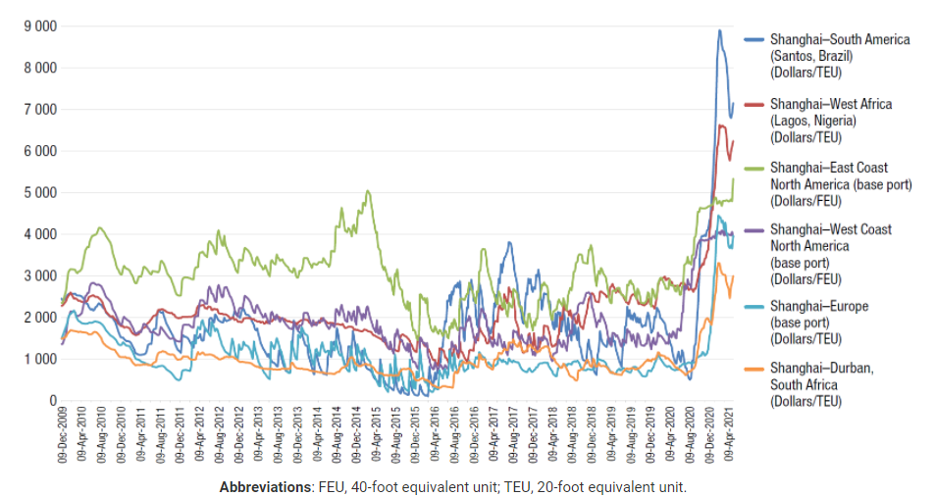
Source: UNCTAD, 2021

Hoffman (2021) further attributes the spike in container freight rates to slower-than-normal container turnaround times in ports and equally slower transport linkages. He also indicates that supply capacity was not increasing fast enough to keep up with demand, and ports’ flexibility is limited compared to shipping lines.
Additional challenges were caused by the decrease in the number of global port calls (Notteboom, Pallis & Rodrigues, 2021). Container vessel calls at ports throughout the world fell by 3.6 percent in the first 30 weeks of 2020 compared to the same time in 2019. The variation in port call reductions can also be seen at the port level. Since COVID-19 was declared a pandemic in mid-March 2020 through July 2020, the percentage of container ports that had a lower number of calls each week approached 40%. A series of blank sailings in long-haul liner services, which can serve as a signal of demand changes, contributed to the documented fall in container vessel calls.
Cullinane and Haralambides (2021) indicates that this pandemic was caused by an unforeseen external shock and it is therefore expected that the world economy will return to pre-COVID-19 levels of activity, and might even surpass them. However, slow economic recovery and continuous reorganisation of global supply chains, according to Notteboom, Pallis and Rodrigues (2021), could encourage shipping lines to rationalise the main East-West routes and develop regional shipping networks in the long run.

- The impact on the ports and shipping industry in South Africa:

President Cyril Ramaphosa proclaimed a national state of disaster in South Africa on March 15, 2020, and announced immediate measures to curb the spread of the virus. By April 20, 2020, two of South Africa's eight seaports (Saldanha Bay and Mossel Bay) were closed to passenger traffic and crew disembarking (Oyenuga, 2021).
The initial closure of international borders for all but the most essential items resulted in a contraction of the economy and the circulation of goods. As a result of movement limitations, trade with South Africa initially declined by 3%, and many shipments were left stranded in ports, yards, and warehouses (Viljoen, 2020; Bezuidenhout 2020).
Eventually commercial ports were reopened and by September 2020 services in ports slowly returned to pre-COVID levels (Pike, 2020). But the effects are far from over. Increased port tariff charges, and continued high international freight rates have had a significant effect on the industry.
The below section analyses the trends in cargo volumes and rates in more detail.

3.1 Trends in cargo volumes and container freight rates in South Africa

During the initial phases of lockdown, port operations were scaled back to 60 percent capacity due to the further drop in imports and exports, and Transnet Freight Rail declared an immediate scale-down of operations (Luke, 2020). The effects remained significant even after the initial hard lockdown in April 2020. Figure 2 provides an overview of the total cargo volumes and the total 6m containers (TEUs) handled by the different ports in South Africa from January 2019 to August 2021 (Transnet, 2021). The data shows the most severe impact of COVID lockdown on cargo flows from April 2020 until July 2020, which corresponds with the time period in which South Africa had its most severe lockdown restrictions in place.

Figure 2: Total cargo (in metric tons) and total TEU flows through South Africa’s ports:
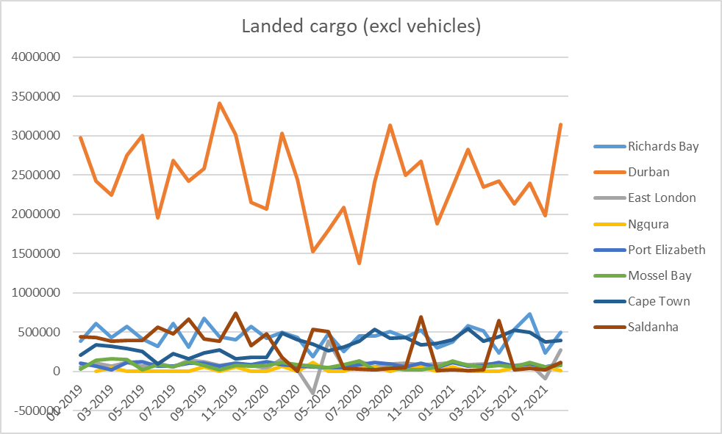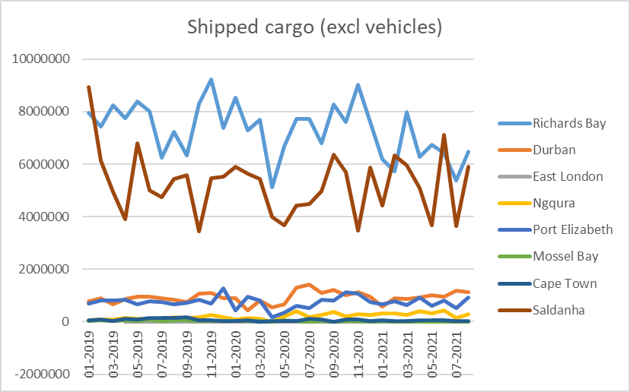
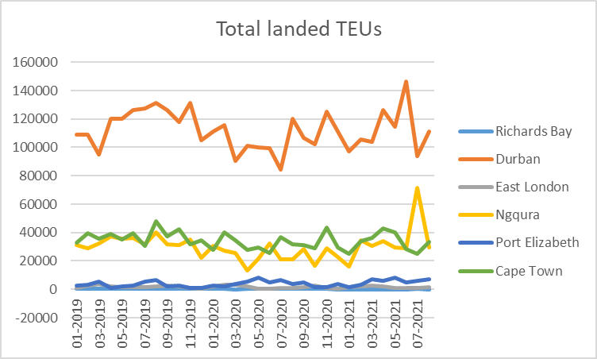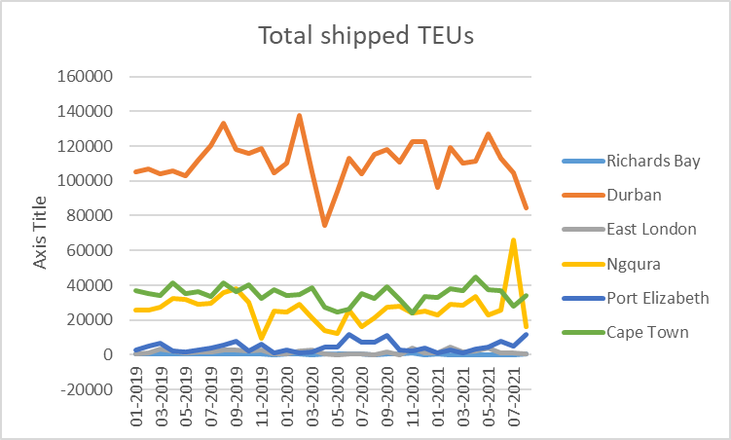
Source: Transnet (2021)

Further data obtained with permission from a local South African freight forwarding company indicates the average 40-foot container freight rates for goods imported through Durban port from 2020 to 2021. Figure 3 shows the drastic impact of the COVID pandemic on container freight rates that this specific company experienced from July 2020, especially for imports from China. Container freight rates almost doubled for goods imported from Italy, and for goods imported from China the container freight rates jumped from R15 395 in July 2020, to just over R60 000 in June 2021.

Figure 3: Average 40-foot container freight rates for imports from China and Italy to Durban: 2020-2021

Source: Author’s own calculations

Venter (2021) reported that the spot rate for a 40-foot container from Shanghai to Los Angeles in August 2021 was 238% higher than during the same period in 2020, reflecting a seriously imbalanced system. Due to international container delays and capacity issues, shipping lines reduced the capacity of South Africa’s trade route, shutting down services and phasing out large vessels to small vessels. Shipping lines also diverted goods destined for the port of Durban, to the ports of Ngqura or Cape Town, or even opted to unload goods at neighbouring Walvis Bay, Luanda or Maputo ports. Venter (2021) emphasises that the inefficiencies at the port of Durban hindered shipping lines’ ability to restore the reliability of their schedules.
Accessibility into the port of Durban itself have also experienced significant delays, with extended time periods of waiting for trucks entering the port. Poor access routes and underdeveloped rail infrastructure cause further problems (Venter 2021).
The following section discusses the issues surrounding port pricing that has also exacerbated the situation.

3.2 Port Pricing in South Africa

The PRSA (2021) annually publishes a Global Pricing Comparator Study for Port Tariffs. It is a benchmarking study with a selection of 25 container ports that compares cargo dues, terminal handling charges and marine services. The benchmarking exercise used a standardised container vessel to calculate vessel calling costs on 1 April 2020. It assumes an average turn-around time of 32 hours and a parcel size of 1 853 TEUs (a combination of full and empty for deep sea, coastwise, and transhipment). The study is useful in monitoring and shaping expectations about the trajectory of port authority pricing in South Africa. Of the total cost to move a TEU through a South African port, terminal handling charges contribute 66%, cargo dues contribute 29%, and marine charges contribute 5% (PRSA, 2021). PRSA (2021) shows that South Africa’s marine charges are 44% below the benchmarked sample average. In stark contrast, terminal handling charges are 55% above the average and cargo dues are 166% above the average. Total port authority pricing, that includes marine services and cargo dues, is 69% above the sample average. PRSA only regulates the NPA and not Transnet Port Terminals. Therefore, only the NPA charges are under price regulation.
The total vessel calling costs (including marine charges, cargo dues and terminal handling charges for containers) decreased from 360% above the benchmarked average in 2012/13 to 65% above the average in 2020/21. Despite the reduction, overall port charges are higher than the average and “remain excessive… indicating that the South African container ports (Durban and Cape Town) remain amongst the most expensive against the sample despite the sizable reduction in container cargo dues in recent years.” (PRSA, 2021, p. 19).
In terms of cargo dues, compared to the benchmarked sample average tariff of US$ 32 7835, South Africa’s ports ranked as 166% more expensive than this average. PRSA (2021, p. 15) explain that “this is an improvement to the 2019 deviation of 233% and a significant improvement to the 2012 tariff where cargo dues were 874% higher than the global sample average. At full implementation of the Tariff Strategy, the cost reflective tariff for containers (as denoted by the Durban target tariff) will be 36% below the global sample average, in today’s terms.”
Gumede and Chasomeris (2018) show that the reason for such excessively high cargo dues was largely because of the legacy of ad valorem wharfage, that was abolished in 2002, but continues to affect the tariff structure. Consequently, there is still cross subsidisation between commodities where automotive and containers appear to cross subsidise bulk and breakbulk cargo handling. In addition, there is cross-subsidisation between user groups where cargo owners appear to cross subsidise port tenants and shipping lines (Gumede and Chasomeris, 2018).
So clearly, there is a desire and a need to reduce port authority charges, in particular cargo dues that are still 166% above the benchmarked mean and a need to implement a tariff strategy that continues to work towards the PRSA goal of cargo dues that are 36% below the benchmarked average. This article uses evidence-based adjustments to RR model variable assumptions and shows (calculates) how the NPA cargo dues can and should be further reduced.

- Revenue Required Methodology in Context

The NPA and PRSA have agreed to use a rate of return methodology referred to as the Revenue Required (RR) model. Annually, there is a tariff adjustment application by the NPA to the PRSA. Since 2009/10, the PRSA invites port users and other interested parties like industry representatives, government departments and academia to provide comments on the tariff applications. The PRSA do their own analyses and research, considers the application and comments and then decides on what tariff (price) adjustments to allowed for the following financial year starting in April.
In South Africa, the South African Reserve Bank uses inflation targeting and aims to keep inflation as measured by the consumer price index (CPI) between 3 and 6%. The PRSA aims to keep NPA price increases below the upper band of 6%. In most years PRSA has been able to use the RR model to ensure weighted average tariff adjustments that are below 6%.
The formula for the RR, as per the Port Tariff Methodology of the Ports Regulator for Tariff Years 2018/19 – 2020/21 (Ports Regulator of South Africa, 2017: 7), is as follows:

RR = (v – d + w) r + D + E + T ± C ± ETIMC ± WEGO ………………………(1)

Where: RR = Revenue Required; v = Value of the assets used in the regulated services; d = Accumulated depreciation on such assets; w = Working Capital; r = Regulated Return on Capital; D = Depreciation accounted for in the period of the tariff; E = Operating costs (OPEX); T = Taxation expense; C = Claw-back; ETIMC = Excessive Tariff Increase Margin Credit; WEGO = Weighted Efficiency Gains from Operations; (v – d + w) = Regulated Asset Base. (Fakir and Chasomeris, 2019).
Chasomeris (2015), Gumede and Chasomeris (2017) and Meyiwa and Chasomeris (2020) provide a detailed discussion and critique of the RR model. In particular, the value of several components of the RR model applied by the NPA and PRSA are contested by port users and stakeholders. There are four variables that this study will focus on, namely the Regulatory Asset Base (RAB), the asset beta, the tax rate to be applied and the ETIMC.
First, there should be a reduction in the RAB by R29 billion and, in order to ensure the sustainability of the NPA, this reduction may need to be phased, perhaps over two or three years. Meyiwa and Chasomeris (2020) explained that there was an approved revaluation of the RAB, using a financial capital maintenance approach, based on historic cost and trended original cost. The NPA estimated that the PRSA Valuation of Assets would reduce the NPA’s opening RAB value at 1 April 2019 by approximately R45 billion from R83.5 billion to R38.1 billion. In 2018/19, a change in the valuation of assets methodology resulted in a R15.8 billion reduction in the RAB. So, what happened to the R29.2bn difference? It appears that there is still scope for RAB value reductions (Chasomeris, 2020). Second, the use of an equitable tax rate of 15.5% should be used as long as the NPA remains a division of Transnet (Fakir and Chasomeris, 2019). Over the period 2011 to 2017, the PRSA allowed the use of the pass-through of corporate tax rate (28%). However, Fakir and Chasomeris (2019) explain that from 2018 it applied an equitable tax rate approach that is derived from the corporate tax rate applied to the group profit, shared between the sums of all the pre-tax profits of profit-making divisions within the group. Fakir and Chasomeris (2019) calculated that over the years from 2011 to 2017, port users could have saved ZAR2.6 billion had the equitable tax rate been applied. Since 2018, the PRSA applied an annual equitable tax rate that is typically in the range from 15 per cent to 15.5 per cent. As soon as the NPA becomes a subsidiary of Transnet, then the corporate tax rate of 28% may be applied. Third, the asset beta should be set to zero rather than the present 0.35. The PRSA historically allowed an asset beta of 0.5, but port users like South African Association of Ship Operators and Agents as well as articles like Chasomeris (2015) and Gumede and Chasomeris (2017) argued for an asset beta lower than 0.5. For the period 2021/22-2023/24, the PRSA are now applying an asset beta of 0.35. However, PRSA (2020: 7) state: “The actual calculated beta of the NPA is closer to 0 due to the reasons set out above”. Moving forward, there could be merit in planned annual reductions in the value of the asset beta (Chasomeris, 2020). Finally, if the RAB, the Asset beta and the correct tax rate are applied, then there would be much less of a need to draw upon the ETIMC. As a result, this would contribute towards a more sustainable use of the ETIMC. Essentially, the funds available in the ETIMC would be available to be used over the coming years to endure that weighted average tariff increases remain low (below CPI inflation increases) and stable.
Tariff adjustments using the RR model are significantly dependent upon trade volumes. The COVID lockdowns, both in South Africa and abroad, substantially reduced port trade volumes. Consequently, the average tariff increase applied for by the NPA was significantly higher. Due to COVID lockdowns and the significantly reduced forecast trade volumes the NPA calculated using the RR model a weighted average tariff increase of 19.4% would be required for the financial year 2021/22. TNPA however acknowledged the extremely difficult economic environment and proposed a weighted average increase of about 3% and made an application to PRSA accordingly. In order for the average tariff increase to be 3% rather than the 19.4%, TNPA requested to use ZAR1.201 billion from the ETIMC. After consultation and analysis, the PRSA ultimately allowed a weighted average increase in tariffs of 0%. Essentially such an outcome was achieved largely by drawing ZAR1.201 billion from the ETIMC. The amount available in the ETIMC in 2019/2020 was ZAR3.158 billion and in 2020/21 it was ZAR2.802. Drawing ZAR1.201 billion in 2021/22 and ZAR1.188 billion in 2022/23 has left only ZAR 645 million in the account (PRSA, 2021b). Obviously drawing so extensively on the ETIMC is not a long-term sustainable strategy for keeping TNPA prices low and stable.
For the 2022/2023 tariff year (1 April 2022 to 31 March 2023), the NPA used the RR model to calculate an increase of 23,96%. However, by asking the Regulator to allow ZAR 1.251 billion to be used/drawn (subsidised) from the ETIMC, the NPA were able to make an application for a weighted average increase of 9.4%. Nevertheless, due to the tariff strategy agreed between the NPA and PRSA, this means that, for example, marine services would increase by 17,83%, coal exports by 12% and automotive trade 0%. Such increases are undesirable for port users and especially shipping lines. Furthermore, the substantial ZAR 1.251 draw down from the ETIMC is not sustainable. Indeed, there is insufficient funds in the ETIMC to allow for another withdrawal of such a magnitude and the NPA application forecasts that they would be able to only draw down about ZAR 499 for the 2023/24 tariff year and ZAR 0 is forecast for the 2024/25 tariff year (TNPA 2021). Accordingly, our scenario analyses show the impact of adjusting the value drawn from the ETIMC on tariffs.
The 2022/23 NPA tariff application of 23.96%, reduced to 9.4% by using the ETIMC, partly shows the impact of COVID lockdowns on lower trade volumes, but also includes an assumption that the NPA is a subsidiary of Transnet and therefore allowed a pass-through of corporate tax at 28%. However, at the time of the NPA application, and the writing of this article, the NPA was still a division and therefore only entitled to use the equitable tax rate (that on average is annually about 15%). In other words, the NPA’s 2022/23 tariff application uses a 28% corporate tax rate and this is incorrect as it should be using an equitable (proportional) tax rate which is about 15%. Accordingly, the following section uses the RR model to calculate the impact on revenues and tariffs of using an equitable tax rate (assumed to be 15.5%) rather than the 28% tax.

- Revenue Required Results and Discussion

This section shows the results from using the RR model to calculate potential NPA revenues and the associated tariff adjustments under five distinct scenarios. The discussion of each scenario, below table 1, begins with a brief explanation about the main differences in assumptions about: the value of the regulatory asset base (RAB), the asset beta, the tax percentage to be used; and the use or not of the ETIMC. Adjusting these values in the RR calculation will then result in significant changes to the revenue required and the associated tariff adjustments.

Table 1. Recalculation of the NPA Tariff Application for 2022/23: Five Scenarios
 | Scenario 1 | Scenario 2 | Scenario 3 | Scenario 4 | Scenario 5
Main differences in RR model variable assumptions: | NPA Application Assumes Asset beta 0,35; present asset base; 28% tax;  No ETIMC | RAB of R78 billion; 0,35 Asset beta; 15.5% proportional tax; No ETIMC | RAB of R78 billion; 0,35 asset beta; 15.5% proportional tax;  ETIMC ZAR 1.2 billion | RAB of R49 billion; 0 Asset beta; 15.5% proportional tax; No ETIMC | RAB of R49 billion; 0 Asset beta; 15.5% proportional tax;  ETIMC of ZAR 1.2 billion
 | R'm | R'm | R'm | R'm | R'm
Opening Net Book Value (1 April) | 78 447 | 78 447 | 78 447 | 49 447 | 49 447
Inflation Indexation | 3 452 | 3 452 | 3 452 | 3 452 | 3 452
CAPEX Indexation
Less: Depreciation | 2 560 | 2 560 | 2 560 | 2 560 | 2 560
Plus: CAPEX Latest Estimate | 2 454 | 2 454 | 2 454 | 2 454 | 2 454
Closing Net Book Value (31 March) | 81 792 | 81 792 | 81 792 | 81 792 | 81 792
Average Asset Base | 80 120 | 80 120 | 80 120 | 65 620 | 65 620
Less: Working Capital | -738 | -738 | -738 | -738 | -738
Regulatory Asset Base | 79 382 | 79 382 | 79 382 | 64 882 | 64 882
Inflation Forecast | 4,35% | 4,35% | 4,35% | 4,35% | 4,35%
Nominal Risk-Free Rate | 9,33% | 9,33% | 9,33% | 9,33% | 9,33%
Real Risk-Free Rate | 4,77% | 4,77% | 4,77% | 4,77% | 4,77%
Market Risk Premium | 5,10% | 5,10% | 5,10% | 5,10% | 5,10%
Asset Beta | 0,35 | 0,35 | 0,35 | 0,00 | 0,00
Equity Beta (using Hamada) | 0,60 | 0,65 | 0,65 | 0,00 | 0,00
Debt Beta | 0,00 | 0,00 | 0,00 | 0,00 | 0,00
Gearing | 0,50 | 0,50 | 0,50 | 0,50 | 0,50
Debt/Equity ratio | 100,00% | 100,00% | 100,00% | 100,00% | 100,00%
Nominal Weighted Average Cost of Debt (WACD) | 10,75% | 10,75% | 10,75% | 10,75% | 10,75%
(Equitable) Tax Rate | 28,00% | 15,50% | 15,50% | 15,50% | 15,50%
Real Post-tax Cost of Equity | 7,84% | 8,07% | 8,07% | 4,77% | 4,77%
Real Pre-tax Weighted Average Cost of Debt | 6,13% | 6,13% | 6,13% | 6,13% | 6,13%
Real Vanilla WACC | 6,99% | 7,10% | 7,10% | 5,45% | 5,45%
Regulatory Asset Base | 79 382 | 79 382 | 79 382 | 64 882 | 64 882
Vanilla WACC | 6,99% | 7,10% | 7,10% | 5,45% | 5,45%
Return on Capital | 5 547 | 5 636 | 5 636 | 3 538 | 3 538
Plus: Depreciation | 2 560 | 2 560 | 2 560 | 2 560 | 2 560
Plus: OPEX | 5 919 | 5 919 | 5 919 | 5 919 | 5 919
Plus: Taxation Expense | 1 211 | 670 | 670 | 670 | 670
Plus/Less: WEGO | -151 | -151 | -151 | -151 | -151
Plus/Less: Clawback | -355 | -355 | -355 | -355 | -355
Plus/Less: ETIMC |  |  | -1 251 | 0 | -1 251
Revenue Allowed | 14 731 | 14 279 | 13 028 | 12 181 | 10 930
Less: Real Estate | -4 085 | -4 085 | -4 085 | -4 085 | -4 085
Marine Revenue | 10 646 | 10 194 | 8 943 | 8 096 | 6 845
Prior Year Revenue | 8 163 | 8 163 | 8 163 | 8 163 | 8 163
Estimated Volume Growth | 5,24% | 5,24% | 5,24% | 5,24% | 5,24%
Revenue after Volume Growth | 8 591 | 8 591 | 8 591 | 8 591 | 8 591
Revenue Required | 10 646 | 10 194 | 8 943 | 8 096 | 6 845
Tariff Increase | 23,93% | 18,66% | 4,10% | -5,76% | -20,32%
Source: Authors own compilation (RR calculation using an excel model adapted from Chasomeris 2015 and Gumede and Chasomeris 2017).

The calculations in Table 1 can be explained as follows:

Scenario 1 recalculates the NPA application to the PRSA using the same variable assumptions used by the NPA application. The value of each of the variables are shown in Table 1. It assumes the presently allowed RAB opening net book value of R78 447 million, an asset beta of 0.35, a tax rate of 28%, and the use of the ETIMC of R1.251 million. The NPA made an application for R10 648 million, however, our calculations in scenario 1 show a revenue required of R10 646 million, a R2 million difference. We believe the difference is due to rounding off errors (or different assumptions about the number of decimal places to use when rounding off). Nevertheless, such a difference would result in a reduction in the tariff increase from 23.96% to 23.93%.

Scenario 2 assumes the presently allowed RAB of R78 447 million, an asset beta of 0.35, an equitable tax rate of 15.5%, and no use of the ETIMC. The results show a required revenue of R10 194 million that translates into an 18.66% increase in tariffs.

Scenario 3 assumes the presently allowed RAB of R78 447 million, an asset beta of 0.35, an equitable tax rate of 15.5%, and an ETIMC of R1.251 million. The calculation results in a required revenue of R8 943 million and a tariff increase of 4.10%.

Scenario 4 assumes that the presently allowed RAB is reduced by R29 billion, that is, the opening RAB is assumed to be R49 447 million. The equitable tax rate of 15.5% is assumed and the asset beta is assumed to be zero. The calculation assumes that there is no use of the ETIMC. The results show a required revenue of R8 096 million and a tariff decrease of 5.76%.
Scenario 5 assumes that the presently allowed RAB is reduced by R29 billion, that is, the opening RAB is assumed to be R49 447 million. The equitable tax rate of 15.5% is assumed and the asset beta is assumed to be zero. In addition, the ETIMC of R1.251 is assumed to be allowed. The results show a required revenue of R6 845 million and a tariff decrease of 20.32%.
The results from the five scenarios show the potential reduction in NPA tariffs. The scenarios show the results of justifiable adjustments in the RR model variable assumptions and values that, for example in the case of scenario 5, could lead to a weighted average tariff decrease of 20.32%.
The PRSA Record of Decision (PRSA, 2021b) ultimately decided to allow an overall 4.8% weighted average tariff increase for 2022/23. This translates into marine services (shipping line) increases of 12%, an increase in dry bulk cargo dues for coal of 11% and magnetite of 15%, but container cargo dues are to remain unchanged and all other tariffs are to increase by 4.2% in line with the expected inflation. To achieve such a tariff adjustment, that is lower than the NPA requested, the PRSA are allowing ZAR1.188 billion to be drawn from the ETIMC. PRSA are treating the NPA as a subsidiary (even though they are not yet a subsidiary) and they are hoping that the NPA becomes a subsidiary within the 2022/23 year. Consequently, PRSA is allowing the use of a 28% tax rate as opposed to the equitable tax rate of just over 15%. Our recommendation is that the NPA should not be treated as a subsidiary of Transnet until it actually becomes a subsidiary. If at some stage during 2022 it does become a subsidiary, then for those months of the year the 28% tax rate could be applied. For the months that it remains a division, it should be treated as such and port users only required to contribute revenues to cover the equitable tax rate of just over 15%. Otherwise, port users will be paying higher taxes and our results show such additional costs (taxes) in excess of ZAR540 million. Such an outcome may result in the TNPA cross-subsidising the Transnet group as it may contribute an unfairly greater portion towards the Transnet group taxes – in a similar way to the first seven years of regulation where port users could have paid ZAR2.6 billion less had the average equitable tax rate of 15.73% been applied rather than the 28% corporate tax rate (Fakir and Chasomeris, 2019).

- Conclusion and Recommendations

The COVID-19 pandemic has created fundamental challenges globally and in South Africa it was exacerbated by a set of other events before and after the COVID-19 pandemic outbreak. Globally one of the greatest impacts was on shipping costs that increased exponentially. South Africa has also felt the impact of these freight rate increases severely, however freight rates are an issue over which local authorities have little control.
This study aimed to analyse the impact of COVID-19 disruptions, and showed the adverse effects of the pandemic, including higher liner freight rates, on South Africa’s ports. The study also highlighted the role of port pricing, NPA tariffs and reduced investments in port infrastructure. These are factors that can be controlled locally to enhance the cost-effectiveness and competitiveness of South Africa’s maritime sector.
The PRSA (2021) benchmarking study shows that South Africa’s port authority charges are 69% above the global benchmarked mean and that cargo dues are 166% above the mean. There is the possibility of reducing NPA tariffs by as much as 20% (see the methodology and results sections). This article provides the justification and evidence to reduce NPA charges at South Africa’s eight commercial ports.
The South African economy experienced a severe recession in 2020, largely due to the extreme COVID-19 lockdown measures imposed. Real GDP declined by seven percent accompanied by significant reductions in trade volumes handled in South Africa’s ports. Section 3.1 shows the decrease in container volumes and parallel increase in container freight rates from 2020 onwards. The reduction in port trade volumes contributed to sharp increases in the NPA tariff applications (19.4% for 2020/21 and 23.96% for 2022/23). NPA capital expenditure investment declined from R1598 million in 2019/20 to R684 million in 2020/21.
For 2022/23, the NPA applied for a weighted average tariff increase of 23.96%. The PRSA allowed an overall 4.8% weighted average increase, but it required using ZAR1.188 billion from the ETIMC (essentially a subsidy) and such a scenario trend of heavily drawing on the ETIMC is not sustainable as there are insufficient funds in the account. Our results from the five RR scenarios examined and justified how the tariff application could and should have been much lower. In the case of the adoption of scenario four, a tariff decrease of 5.76% and in the case of scenario five a 20.32% tariff decrease.
In sum, based on the evidence, our main recommendations are as follows. First, there should be a reduction in the RAB by R29 billion and this reduction may be phased, perhaps over two or three years. Second, the use of an equitable tax rate of 15.5% should be used as long as the NPA remains a division of Transnet. As soon as the NPA becomes a subsidiary of Transnet, then the corporate tax rate of 28% may be applied. Third, the asset beta should be set to zero rather than the present 0.35. Finally, if the RAB, the Asset beta and the correct tax rate are applied, then there would be much less of a need to draw upon the ETIMC. As a result, this would contribute towards a more sustainable use of the ETIMC, ensuring that average tariff increases remain below inflation. Implementing these recommendations should result in a real decrease in NPA tariffs, particularly cargo dues, hence benefiting port users and contributing to the goals of the PRSA and the NPA. Indeed, our calculations showed in Scenario five that it is even possible to reduce the NPA weighted average tariff by 20.32%. Such reductions in port charges are not only justifiable, but also desirable as it promotes the feasibility, sustainability and competitiveness of companies that trade through South Africa’s ports, especially post-COVID as part of the recovery path of the local supply chains.

References:

Baldwin, R. and Freeman, R. 2020. Supply chain contagion waves: Thinking ahead on manufacturing ‘contagion and reinfection’ from the COVID concussion. https://voxeu.org/article/covid-concussion-and-supply-chain-contagion-waves. Accessed on: 23 August 2021.
Baldwin, R. and Tomiura, E. 2020. Thinking ahead about the trade impact of COVID-19. Economics in the Time of COVID-19, 59.
Bezuidenhout, J., 2020. Covid-19 lockdown: A moving target for importers. https://www.dailymaverick.co.za/article/2020-03-25-covid19-lockdown-a-moving-target-for-importers/ Accessed on: 23 August 2021.
Chasomeris, M. (2015) Port Infrastructure Pricing: A Critique of the Revenue Required Methodology. International Journal of Transport Economics. Vol. XLII. No2. June 2015. pp 153-170. Publisher: Fabrizio Serra editore: Rome.
Chasomeris, M. (2020) Comments on the National Ports Authority Revenue Required Tariff Methodology 2021/22 and Beyond, at the Ports Regulator of South Africa Workshop, Umhlanga, 5 February 2020. Available at: https://www.portsregulator.org/doc/UKZN-Chasomeris-Port-Tariff-Methodology-2021-22-and-Beyond.pdf. Accessed on: 15 May 2021.
Chasomeris M., Gumede S. (2022) Regulation, Governance and Infrastructure Pricing in South Africa’s Ports Sector. In: Ferrari C., Haralambides H., Prete S., Tei A. (eds) Regulation and Finance in the Port Industry. Palgrave Studies in Maritime Economics. Palgrave Macmillan, Cham. https://doi.org/10.1007/978-3-030-83985-7_4.
Cullinane, K. and Haralambides, H. 2021. Global trends in maritime and port economics: the COVID-19 pandemic and beyond. Maritime Economics & Logistics, 23:369-380.
Drewry. 2021. Industry at a glance: World Container Index. https://www.drewry.co.uk/coronavirus-hub. Accessed on: 23 August 2021.
Gumede, S. and Chasomeris, M. (2015). “Maritime Port Pricing and Governance: Trends and Stakeholder Comments”, Journal of Economic and Financial Sciences, 8:1, 47-62.
Gumede, S. and Chasomeris, M. (2017a). Regulation of South Africa’s Ports: Dilemmas and Reforms. International Association of Maritime Economists Conference. Kyoto, 27-30 June.
Gumede, S. and Chasomeris, M. G. (2017b). A Critique of South Africa’s National Ports Authority’s Revenue Required Pricing Methodology. International Journal of Transport Economics, 44(4).
Gumede, S. & Chasomeris, M. (2018). Pricing strategy and tariff structure for a port authority: a case study of South Africa. Maritime Policy & Management, 45:6, 756-769, DOI: 10.1080/03088839.2018.1446103.
Fakir, M., and M. Chasomeris. 2019. Ports regulation in South Africa: a new equitable tax rate approach. In Presented at International Association of Maritime Economics (IAME) conference, 25–28 June. Athens: Greece.
Hoffman, J. 2021. How to cushion consumers from high maritime freight rates. How to cushion consumers from high maritime freight rates | UNCTAD. Accessed on: 21 September 2021.
Luke, R. 2020. The impact of COVID-2019 on transport in South Africa. Journal of Transport and Supply Chain Management, 14(1), pp.1-5.
Makokera, C.G. and Makokera, M. 2020. South Africa’s trade policy post COVID-19. SAIIA Policy Briefing No 206, September. https://saiia.org.za/research/south-africas-trade-policy-post-covid-19/ Accessed on: 20 October 2021.
Meyiwa, A. and Chasomeris, M., 2020. South Africa’s port doctrine: dilemmas and the way forward. Maritime Studies, 19(2), pp.179-191.
Notteboom, T., Pallis, T. and Rodrigue, J.P., 2021. Disruptions and resilience in global container shipping and ports: the COVID-19 pandemic versus the 2008–2009 financial crisis. Maritime Economics & Logistics, 23(2), pp.179-210.
Oyenuga, A. 2021. Perspectives on the impact of the COVID-19 pandemic on the global and African maritime transport sectors, and the potential implications for Africa’s maritime governance. WMU Journal of Maritime Affairs (2021) 20:215–245.
Ports Regulator of South Africa (2017) Port Tariff Methodology For Tariff Years 2018/19 – 2020/21, available at: https://www.portsregulator.org/images/documents/Final-Tariff-Methodology-1819-2021.pdf. Date accessed: 6 October 2018.
PRSA (2020) Port Tariff Methodology for Tariff Years 2021/22 – 2023/24. Published March 2020. https://portsregulator.org/doc/Port-Tariff-Methodology-For-Tariff-Years-2021-22_2023-24.pdf. Accessed on: 30 March 2020.
PRSA (2021). Global Pricing Comparator Study 2020/21. Port Tariffs. Benchmarking South African port administered prices against a sample of international ports. Report No. 9. https://docplayer.net/215775745-Global-pricing-comparator-study-2020-21-port-tariffs.html. Accessed on: 28 March 2022.
PRSA (2021) Record of Decision. Tariff Application by the National Ports Authority for the Tariff Years 2022/23 – 2024/25. https://portsregulator.org/doc/Ports-Regulator-2022-2023-Tariffs-Record-of-Decision.pdf. Accessed on: 28 March 2022.
Pike, A. 2020. COVID-19: South Africa – signs of improvement in shipping. Bowmans Opinions and Analysis, Sept 8, 2020. https://www.bowmanslaw.com/insights/shipping-aviation-and-logistics/covid-19-south-africa-signs-of-improvement-in-shipping/ Accessed on: 21 September 2021.
Smith, C. 2021. Transnet cyberattack: main ports at 100% but warehousing and cold storage still impacted. Fin24, Jul 30. https://www.news24.com/fin24/economy/transnet-cyberattack-main-ports-at-100-but-warehousing-and-cold-storage-still-impacted-20210730.
Transnet. 2021. Port Statistics. https://www.transnetnationalportsauthority.net/Commercial%20and%20Marketing/Pages/Port-Statistics.aspx. Accessed on: 23 August 2021.
UNCTAD. 2020. Impact of the COVID-19 Pandemic on Trade and Development: Transitioning to a New Normal. https://unctad.org/system/files/official-document/osg2020d1_en.pdf. Accessed on: 23 August 2021.
UNCTAD. 2021a. COVID-19 and maritime transport: impact and responses. Transport and Trade Facilitation, Series 15. https://unctad.org/system/files/official-document/dtltlb2021d1_en.pdf.
UNCTAD. 2021b. Shipping during COVID-19: Why container freight rates have surged. https://unctad.org/news/shipping-during-covid-19-why-container-freight-rates-have-surged. Accessed on: 23 August 2021.
The World Bank. 2021. “The Container Port Performance Index 2020: A Comparable Assessment of Container Port Performance.” World Bank, Washington, DC. License: Creative Commons Attribution CC BY 3.0 IGO.
TNPA (2021). Transnet National Ports Authority Tariff Application FY 2022/23 to FY 2024/25, Roadshow Presentation 14 – 16 September 2021, Accessed at: https://portsregulator.org/tariffs-2022-23-tnpa-tariff-application/. Accessed on: 24 February 2022.
Venter, I. 2021. Durban port woes amplified as global supply chain crunch intensifies. Creamer Media’s Engineering News, Oct 21. https://www.engineeringnews.co.za/article/durban-port-woes-amplified-as-global-supply-chain-crunch-intensifies-2021-10-21/rep_id:4136.
Veselovská, L. 2020. Supply chain disruptions in the context of early stages of the global COVID-19 outbreak. Problems and Perspectives in Management, 18(2), pp.490-500.
Viljoen, W. 2020. South Africa’s trade for March 2020 – Significant trade surplus shows the initial impact of COVID-19 on imports, viewed 09 September 2020. https:// www.tralac.org/blog/article/14591-south-africa-s-trade-for-march-2020-significanttrade-surplus-shows-the-initial-impact-of-covid-19-on-imports. html#:~:text=The % 20impact % 20of % 20the % 20Covid,and % 2 0 trade%2Dcentred%20less%20around.
World Bank. 2022. Global Economic Prospects, January 2022. Washington, DC: World Bank. doi: 10.1596/978-1-4648-1758-8. License: Creative Commons Attribution CC BY 3.0 IGO.

