Monday, September 12, 2022

Author: Lamola Kingston Xerxes Theophilus
Ref. No. : 708
Good Day Editor, Ms. Taylor.

Manuscript title: Employees’ Aptitudes and Trepidations for the Adoption
of Enterprise Application Architecture for Supply Chain Management in Small
and Medium Enterprises: A Case of Capricorn District Municipality
Journal: Journal of Transport and Supply Chain Management

 | REVIEWERS’ A COMMENTS
AQS | Reviewer’s Notation | Corrections Status | Author’s  Notation
AQ1 | The author has provided definitions for “ER, SAP, and SMME”. The copyeditor meant expansions for these terms but mentioned to define them. Should we have to insert the definitions or insert only the expansions. Kindly check and confirm. | Yes, both expansions and definitions that could help the reader(s) to have a vivid understanding. | Yes
AQ2 | The author has provided explanations for the in-text citations in Table 1 and 2; Appendix A and B. Should we have to insert these paragraphs. Kindly check and confirm. | Please do so. | Yes
AQ3 | The following reference is cited in text, but not provided in reference list (Green 2014). Please check and provide. | Please update citation as; Green, Agarwal & Logue, 2015). | Green, R., Agarwal, R. & Logue, D., 2015, ‘Learn more about diffusion theory of technology: Innovation’, viewed 15 April 2019, from: https://www.sciencedirect.com/topics/social-sciences/diffusion-of-technology (accessed 15 April 2019).
AQ4 | Figure ,2 is cited in the text but not provided. Please provide Figure 2 at an appropriate place. | Please find  (attach it under Stability diagnostics test) | 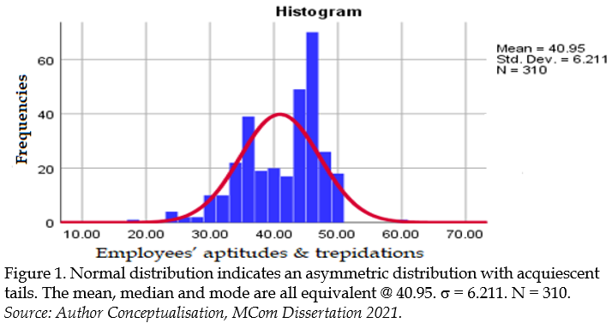
Additional corrections
Cover paper | Please add the other initial. It should be Kingston X.T. Lamola | I have three names.
Your positive feedback will be highly appreciated.
Keep well.

