# | Instance | Results | CVRPfC
1 | E016-03m | Objective Function: 339.5481 | 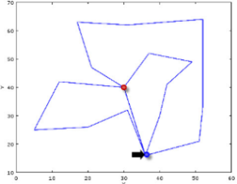
 | Dimension  16 | Routes 1 O_{B} 1 2 11 5 D_{A} O_{B}  2 O_{B} 6 7 8 3 9 10 D_{A} O_{B}  3 O_{B} 14 13 4 12 D_{A} O_{B}
Capacity
90
Vehicles
3
2 | E016-05m | Objective Function: 470.4268 | 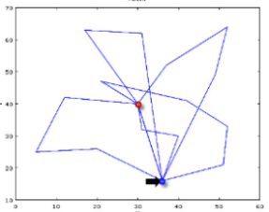
 | Dimension  16 | Routes 1 O_{B} 1 3 2 D_{A} O_{B}  2 O_{B} 6 11 9 10 D_{A} O_{B}  3 O_{B} 7 8 D_{A} O_{B}  4 O_{B} 12 5 D_{A} O_{B}  5 O_{B} 14 13 4 D_{A} O_{B}
Capacity
55
Vehicles
5
3 | E021-04m | Objective Function: 483.5574 | 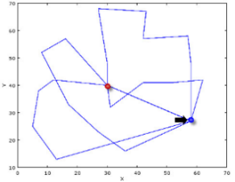
 | Dimension  21 | Routes 1 O_{B} 2 1 6 11 D_{A} O_{B}  2 O_{B} 4 15 3 9 D_{A} O_{B}  3 O_{B} 13 14 8 7 5 D_{A} O_{B}  4 O_{B} 17 16 18 12 10 19 D_{A} O_{B}
Capacity
85
Vehicles
4
4 | E021-06m | Objective Function: 640.441 | 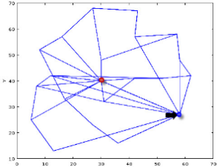
 | Dimension  21 | Routes 1 O_{B} 1 6 D_{A} O_{B}  2 O_{B} 4 3 9 D_{A} O_{B}  3 O_{B} 8 7 5 D_{A} O_{B}  4 O_{B} 14 13 16 18 12 D_{A} O_{B}  5 O_{B} 15 2 D_{A} O_{B}  6 O_{B} 17 10 19 11 D_{A} O_{B}
Capacity
58
Vehicles
4
5 | P-n16-k8 | Objective Function: 643.5748 | 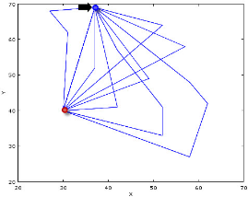
 | Dimension  16 | Routes 1 O_{B} 1 D_{A} O_{B}  2 O_{B} 2 D_{A} O_{B}  3 O_{B} 3 12 D_{A} O_{B}  4 O_{B} 4 11 D_{A} O_{B}  5 O_{B} 5 7 10 D_{A} O_{B}  6 O_{B} 6 D_{A} O_{B}  7 O_{B} 8 D_{A} O_{B}  8 O_{B} 14 9 13 D_{A} O_{B}
Capacity
35
Vehicles
8
6 | P-n19-k2 | Objective Function: 213.4269 | 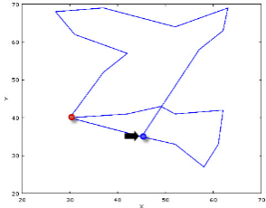
 | Dimension  19 | Routes 1 O_{B} 1 10 4 11 14 12 3 17 16 8 D_{A} O_{B}  2 O_{B} 6 2 7 9 15 13 5 D_{A} O_{B}
Capacity
160
Vehicles
2
7 | P-n20-k2 | Objective Function: 224.2078 | 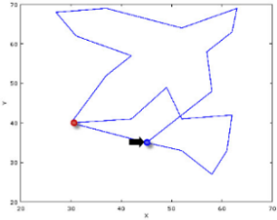
 | Dimension  20 | Routes 1 O_{B} 1 10 4 11 15 12 3 18 17 8 13 D_{A} O_{B}  2 O_{B} 6 2 7 9 16 14 5 D_{A} O_{B}
Capacity
160
Vehicles
2
8 | P-n21-k2 | Objective Function: 224.7469 | 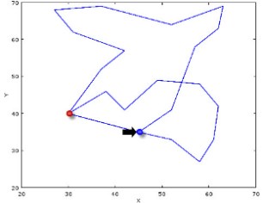
 | Dimension  21 | Routes 1 O_{B} 1 10 4 11 15 12 3 19 18 8 7 D_{A} O_{B}  2 O_{B} 16 6 2 13 9 17 14 5 D_{A} O_{B}
Capacity
160
Vehicles
2
9 | P-n22-k2 | Objective Function: 242.4456 | 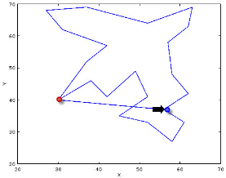
 | Dimension  22 | Routes 1 O_{B} 1 10 4 11 15 12 3 19 18 8 13 9 D_{A} O_{B}  2 O_{B} 16 6 2 7 20 5 14 17 D_{A} O_{B}
Capacity
160
Vehicles
2
10 | P-n23-k8 | Objective Function: 633.3429 | 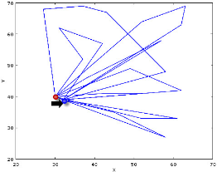
 | Dimension  23 | Routes 1 O_{B} 1 4 11 D_{A} O_{B}  2 O_{B} 2 9 D_{A} O_{B}  3 O_{B} 3 19 18 D_{A} O_{B}  4 O_{B} 5 17 D_{A} O_{B}  5 O_{B} 6 7 D_{A} O_{B}  6 O_{B} 11 15 12 13 D_{A} O_{B}  7 O_{B} 16 8 D_{A} O_{B}  8 O_{B} 21 20 14 D_{A} O_{B}
Capacity
40
Vehicles
8

FIGURE 4: Solutions of the Capacitated Vehicle Routing Problem for Carriers model on adapted Vehicle Routing Problem LIBrary test problems.

